Pedrotti Gonzalo. English II

Absolut Vodka Fernet Branca
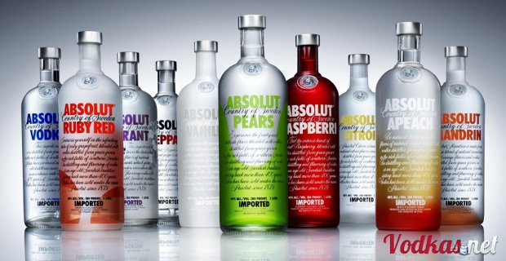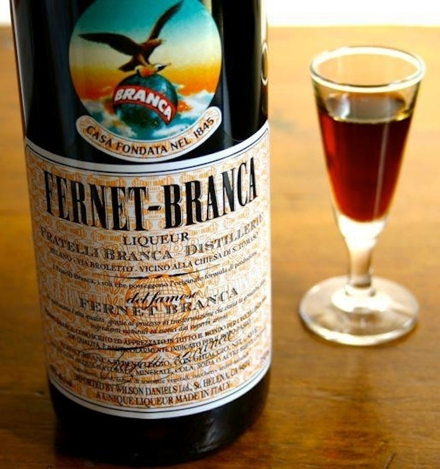
Origin: Sweden Origin: Milan, Italy
Launched: 1879 Launched: 1845
Bottle: 700 and 1000 ml Bottle: 500, 750 and 1000 ml
Alcohol Content: 40% Alcohol Content: 39%
Price: $300 Price: $120
Some Models: Has Two model: Black and mint
Blue label
Red Label
Vanilia
Raspberry
Apeach
Ruby Red
Pears

Absolut was launched in 1879, and Branca was launched in 1845, so Branca is older than Absolut.
Fernet Branca is more bitter than vodka Absolut and is less strong than Absolut.
Also, the Branca Fernet is less strong than Absolut.
Absolut has more flavors than Branca Fernet, and Absolut is more expensive than Branca Fernet.
Branca has more models of bottle than Absolut

